*Florida International University*

*School of Computing and Information Sciences*

Software Engineering Focus

Feature Document

User Story ID <NVOS-2 BASE UI>

**Name:** Bryan Bastida

**Team Member(s):** Bryan Bastida

Andrew Castillo

**Project:** Envo Scholar

**Product Owner(s)**: Mark Finlayson

**Mentor(s)**: Masoud Sadjadi

**Instructor**: Masoud Sadjadi

**User Story Name: Base UI**

* As a user, I want to use a UI that allows for query entry and displays the results, so that the I can obtain the results I am looking for.

Acceptance Criteria

* User has opened up the Envo Scholar webpage.
* User types a search query into the search bar and clicks the search button.
* Results are displayed to the screen.

**Use Case**

* **Name**: Base UI
* **Actor**: User and Web Page
* **Preconditions**: User has opened up the Envo Scholar webpage
* **Description** <Flow of events>:
  + User types a search query and hits the Search button
  + Search query is sent to the database
  + Database returns articles
  + Web page displays article links, view pdf links, and citation links.

**Use Case Diagram**

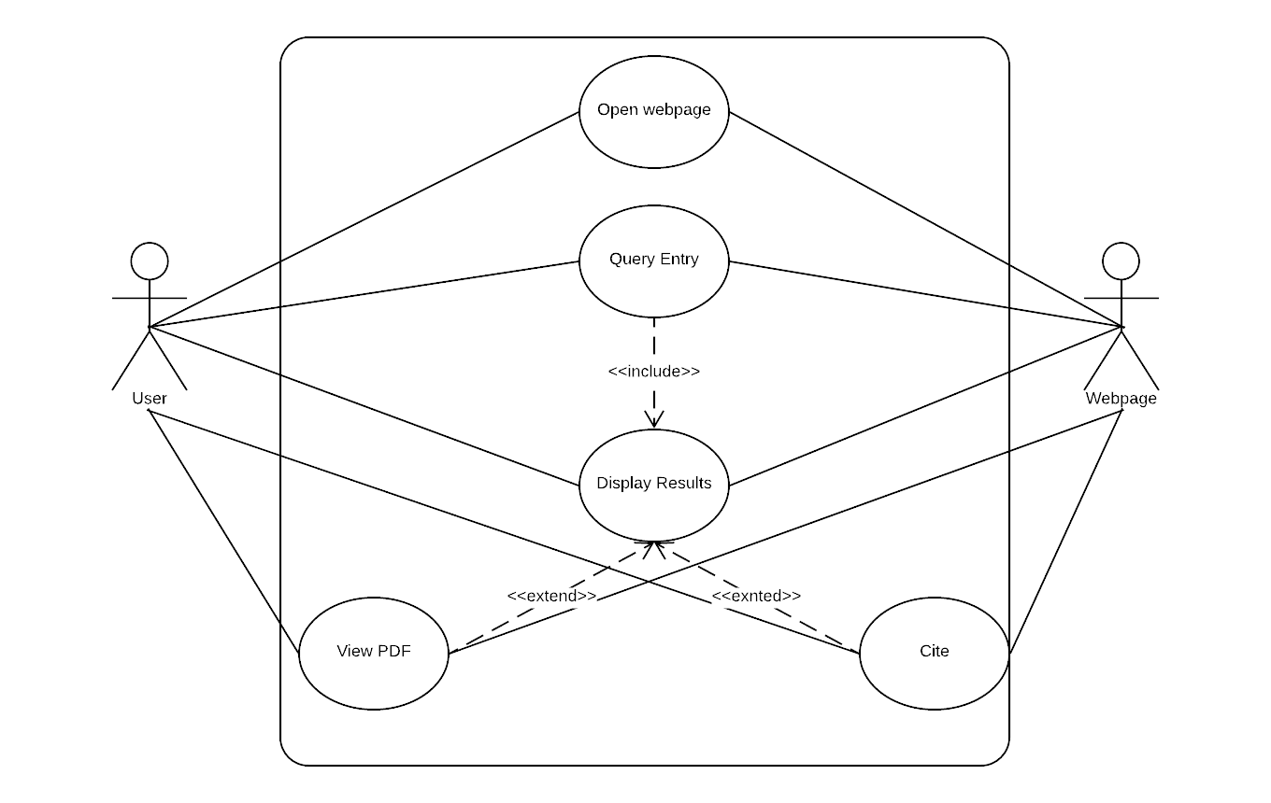

**Sequence Diagram**

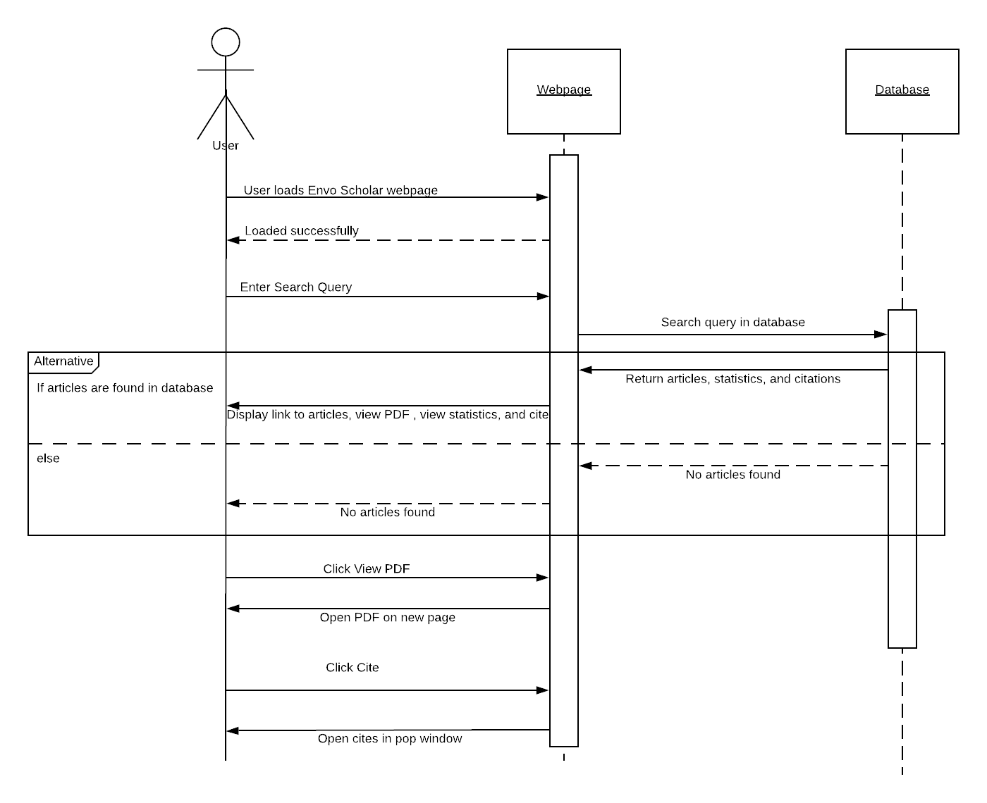

**Class Diagram**

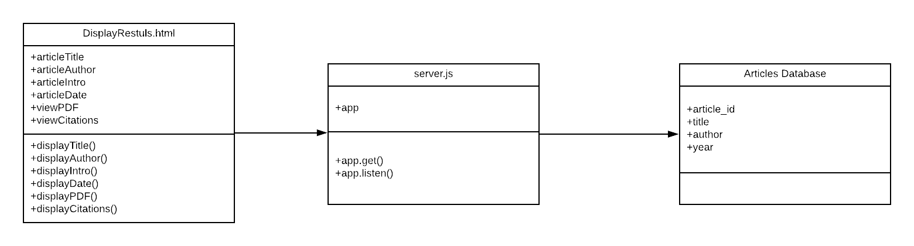

**Visual User Guide** <like one or two screenshots of the feature. For the hardware project, a photo of device is required>

